December 9, 2025

Dear Governor-Elect Spanberger,
We, the undersigned organizations, are writing to express our concerns regarding the creation and implementation of a Prescription Drug Affordability Board (PDAB) in Virginia. Our organizations represent patients with rare and chronic diseases as well as the providers that care for them. Although well-intentioned, we feel strongly that a PDAB could actually lead to more restricted access for patients or even the elimination of treatment options altogether.
Legislation to authorize a PDAB has been under consideration by the General Assembly for several years and we anticipate this legislation will be re-introduced in the 2026 Session. While we applaud the Members’ goal of addressing affordability challenges in the health care space, a PDAB is not the silver bullet solution it has been portrayed to be.
Before we look to Virginia, it’s important to shed light on the status of PDABs in other states and, most importantly, that as of the date of this letter no patient or state has saved a dime. In fact, they have only cost money. In these challenging budget times Virginia should consider carefully such a heavy expenditure when there is absolutely no guarantee of savings from an untested theory.
Concerning PDAB Activity in other States:
Oregon and Maryland: Discussions and comments from PDAB Board Members that an Upper Payment Limit (UPL) may not be as effective as once thought. A current component of a proposed PDAB in Virginia, a UPL would be the maximum amount purchasers and payers could be required to pay for a specific medication. It’s important to note a UPL only deals with what an insurance plan can pay for that medication not the actual cost of acquiring and stocking it. This could create several access challenges for healthcare providers who administer complex drugs, pharmacies, patients who receive shipped medication from other states, and/or those that receive specialized care/treatment at an out of state facility.
Colorado, Maine, Massachusetts, Minnesota, New Jersey, New York, Ohio, and Washington: No money saved for patients.
In fact, in 2025, New Hampshire: PDAB repealed in 2025. Concerns cited included state expenditures vs. savings generated. And, in the 2025 legislative recommendations, the Oregon PDAB vice chair recommended repealing the program due to cost and access concerns.

It is important to understand that PDAB’s only deal with one part of a long supply chain that includes pharmaceutical manufacturers, PBM’s, employers, health insurers, pharmacists, and patients. Each step in this process relies heavily on the preceding step. Focusing on only one risks a short-sided review of affordability excluding several entities who have large parts to play in what patient pays out of pocket at the pharmacy counter. Can Virginia really rely on savings to “trickle down” to patients with no guarantee and a track record of failure in other states?
In addition to the supply chain, other health care programs in the state may also be negatively affected by a PDAB setting a UPL. These include the Medicaid Program and the 340B Program. With so many unknowns and no positive results from other states, even after many years of operation, we urge Virginia to study this matter more before moving ahead. The Virginia Joint Commission on Healthcare (JCHC) would be an appropriate venue to take a more in depth look at what other states have done, how Virginia might be affected by a PDAB and UPLs, and which solutions make sense and can lower costs for patients.
We urge Members to also look to proven solutions that will help patients facing affordability challenges while not causing harm. These include health insurance benefit design (copay vs co-insurance model), delinking PBM compensation from the price of the drug, and ensuring rebates received by PBM’s flow to the patient.
As patients and providers in the chronic and rare disease space, we know more acutely than anyone the affordability challenges that exist regarding out-of-pocket expenses. We also know how complex and interconnected the supply chain is and that access to what a doctor prescribes for a patient is paramount. We hope to work with you to look deeper into why these out-of-pocket expenses are unaffordable and how we can develop solutions that can save patients and other stakeholders money. But first, we must do no harm. A PDAB is not the solution.
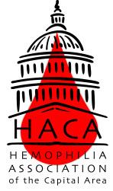
Thank you for your time and attention to this important matter. Please let us know if you have any questions or would like to discuss any of the information presented in greater detail.
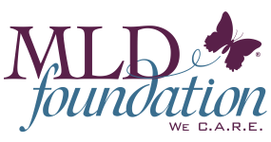
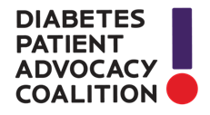
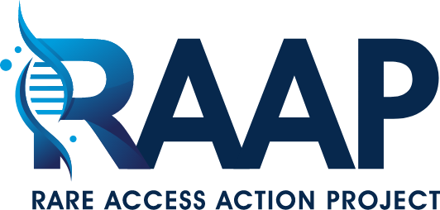
Sincerely,


